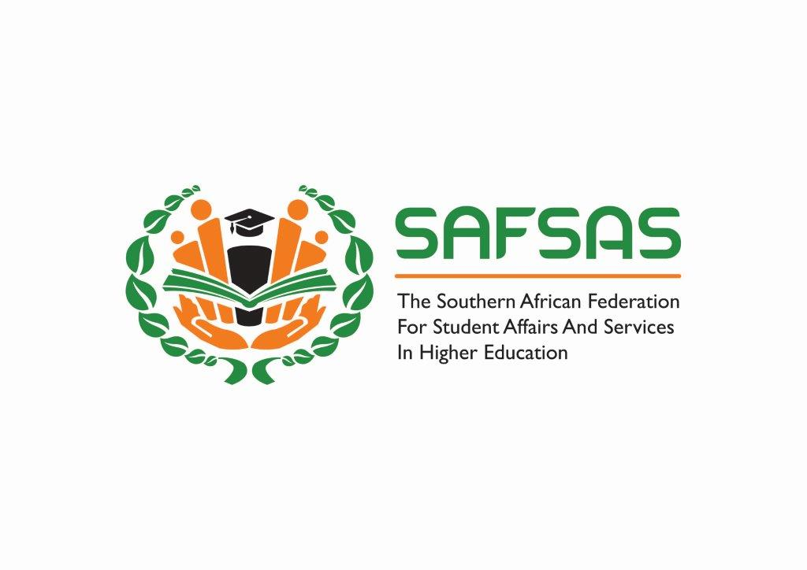

**SAVE THE DATE**

**SAFSAS SUMMIT 2018**

***“Looking back, looking forward: Understanding our space and our role in the new normal”***

**26th – 27th November 2018**

**Coastlands Umhlanga Hotel and Conference Centre**

**Durban, KZN - South Africa**

**Affiliate Member Organizations will engage with the key theme and subthemes**

**SAFSAS members, Student Affairs practitioners and staff in Higher Education are welcome**

***SAFSAS SUMMIT ORGANISING COMMITTEE***

***Dr Saloschini Pillay***

[***pillaysl@ukzn.ac.za***](mailto:pillaysl@ukzn.ac.za)

***0312607087/7681***

**Details to follow**